
Applent AT526 1 kHz ESR Measurement SOP
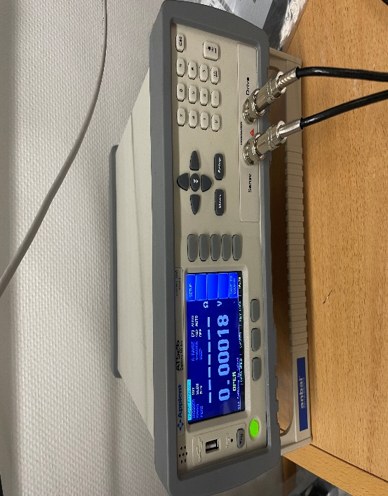
Data | 12.09.2025
Version | 01
Prepared by
Battery Test Engineer | Zawar Qureshi
Agreed by
Technical Director | Anton

Contents
1) Purpose & Scope 3
2) Safety & Handling 3
3) Environment & Instrument Setup 3
4) Copper Shorting Bar — Cells only 3
4.1 Material & Finish 3
4.2 Geometry of Short bar for Cells (target R_{bar} ≤ 0.01 mΩ) 3
4.3 Clamping & Hardware 4
5) Copper Shorting Bar — Blocks only 4
5.1 Material & Finish 4
5.2 Geometry of Short bar for blocks (target R_{bar} ≤ 0.01 mΩ) 4
5.3 Clamping & Hardware 4
6) Clip Landing Geometry (repeatable pose) 5
7) Short‑circuit Clear Zero (AT526 built‑in) — do whenever pose/leads change 5
7.1 OPEN check (sanity only) 5
7.2 SHORT correction (cells/blocks with copper bar) 5
8) Measurement Procedure — Cells 5
9) Measurement Procedure — Blocks 6
10) Troubleshooting 6
11) Rationale (quick refresher) 6

1) Purpose & Scope
Provide a complete, repeatable method to measure ESR@ 1 kHz (HFR) on:
- Cells with two 50×50 mm copper tabs.
- Blocks with radiators/busbars.

2) Safety & Handling
- Discharge DUT to ≤50 mV before any measurement.
- Insulate tools; prevent accidental +/− contact.
- Keep leads and bar dry/clean.

3) Environment & Instrument Setup
- Warm‑up: Power AT526 ≥30 min (≥60 min for tightest accuracy).
- Speed: Use SLOW for most stable/accurate readings.
- Jaw mapping (once per cable, verify monthly): Wire side up for both clips.
- Polarity convention: Red clip = + terminal; Black clip = − terminal.

4) Copper Shorting Bar — Cells only
Purpose: Provide an ultra‑low, stable short during Short‑circuit Clear Zero so the meter subtracts lead/clip series exactly in the final pose.

4.1 Material & Finish
- Material: OFHC copper (C101/C110) bar.
- Finish: Bright, smooth faces. Optional thin Sn or Ag flash to reduce oxidation. Keep faces clean and flat.

4.2 Geometry of Short bar for Cells (target R_{bar} ≤ 0.01 mΩ)
Let L = span between bite points (tab‑to‑tab), t = thickness, w = width. Resistance:
$R_{bar}=\frac{ρ_{cu}L}{tw}$ , with ρ_{Cu} = 1.68×10⁻⁸ Ω·m.
Recommended bar size:
- L (80–110 mm): t = 5 mm, w = 30 mm.
- Example L = 90 mm → R ≈ 0.010 mΩ.
Rule of thumb: If R_{bar} ≤ 0.01 mΩ, its contribution is far below cell ESR and is fully removed by Clear‑Zero.

4.3 Clamping & Hardware
- Torque: 2.0–2.5 N·m into copper (do not over‑torque thin tabs). Use identical torque on both sides.
- Contact prep: IPA wipe → dry. Ensure full‑face contact, no burrs.
- Insulation / clearance: Use Kapton or plastic spacers so the bar cannot touch the fixture or other metal.

5) Copper Shorting Bar — Blocks only
Purpose: Provide an ultra‑low, stable short during Short‑circuit Clear Zero so the meter subtracts lead/clip series exactly in the final pose.

5.1 Material & Finish
- Material: OFHC copper (C101/C110) bar.
- Finish: Bright, smooth faces. Optional thin Sn or Ag flash to reduce oxidation. Keep faces clean and flat.

5.2 Geometry of Short bar for blocks (target R_{bar} ≤ 0.01 mΩ)
Let L = span between bite points (tab‑to‑tab), t = thickness, w = width. Resistance:
$R_{bar}=\frac{ρ_{cu}L}{tw}$ , with ρ_{Cu} = 1.68×10⁻⁸ Ω·m.
Recommended bar size:
- L (50 mm): t = 5 mm, w = 30 mm.
- Example L = 50 mm → R ≈ 0.008 mΩ.
Rule of thumb: If R_{bar} ≤ 0.01 mΩ, its contribution is far below cell ESR and is fully removed by Clear‑Zero.

5.3 Clamping & Hardware
- Torque: 2.0–2.5 N·m into copper (do not over‑torque thin tabs). Use identical torque on both sides.
- Contact prep: IPA wipe → dry. Ensure full‑face contact, no burrs.
- Insulation / clearance: Use Kapton or plastic spacers so the bar cannot touch the fixture or other metal.

6) Clip Landing Geometry (repeatable pose)
- Cells (tabs): Place each clip 3 ± 1 mm from the tab root; TOP face = Sense jaw, BOTTOM face = Drive jaw. Keep clip angle perpendicular to the tab edge. Mirror left/right.
- Blocks (radiators/busbars): Land diagonally over the long side of the block; keep TOP = Sense, BOTTOM = Drive.
- Keep bar contact as close as practical to where the AT526 clips will land. Aim for < 10 mm from each SENSE Jaw. Maintain geometry.
- Surface prep (once per DUT per session): IPA wipe → dry.

7) Short‑circuit Clear Zero (AT526 built‑in) — do whenever pose/leads change
AT526 uses Short‑circuit Clear Zero. An OPEN check is simply clips not touching anything and reading OPEN/over‑range.

7.1 OPEN check (sanity only)
- Clips not touching anything (or closed on a plastic card). Reading should indicate OPEN/over‑range.

7.2 SHORT correction (cells/blocks with copper bar)
- Install the copper shorting bar across + and − tabs; clamp as per 4.3/5.3 (same surfaces you will measure).
- Mount clips in their final pose (Sense=TOP, Drive=BOTTOM, 3±1 mm from root for cells and 10±1 mm from stack for blocks). Do not move them after this.
- On the AT526: [SETUP] → [CLEAR ZERO]. Wait for PASS.
- Verify: With the bar still installed, a quick read should be ~0 mΩ (± instrument noise). If not, re‑seat/clean and repeat Clear‑Zero.
Key principle: Clear‑Zero subtracts the measured short (leads + clips + bar) from subsequent readings, effectively moving the reference plane to your sense jaws in that exact pose.

8) Measurement Procedure — Cells
- Warm‑up verified; SLOW speed set.
- Pressure: Set fixture compression to lab standard (e.g., 2 kg F/cm²). Record.
- Clear‑Zero per 7.2.
- Remove the short bar without moving the clips. Re‑check clip position visually.
- Wait 10 s for mechanical/thermal settle.
- Trigger three readings (≥2 s apart). Record R1, R2, R3, mean, stdev.
- Acceptance: If (max–min) > 2% of mean, re‑land once (same pose) → redo 7.2 → re‑measure.
- Log ambient T (°C), pressure, pose ID, operator.
Reporting: ESR(1 kHz) = mean ± stdev (mΩ) @ T/pressure/pose.

9) Measurement Procedure — Blocks
- Ensure busbars are torqued to spec; block is discharged ≤50 mV.
- Place clips in Blocks pose (TOP=Sense, BOTTOM=Drive, diagonal over the long edge). Prep surfaces.
- Run Clear‑Zero per 7.2 with a stout bridge across terminals.
- Remove bridge without moving clips; wait 10 s; acquire three readings; apply same acceptance rule.
- For per‑cell estimate: R_{per‑cell} = (R_{block} − R_{ends}) / N.
- Ends/bus terms are amortized, so R_{per‑cell} appears lower than stand‑alone cell ESR.

10) Troubleshooting
- Reading ≠ ~0 mΩ during Clear‑Zero: Bar dirty/loose; clips not on clean metal; redo 4.3/5.3 prep; repeat Clear‑Zero.
- Large scatter (>2%): Non‑mirrored landings; moved after Clear‑Zero; oxide; insufficient pressure; warm‑up incomplete.
- Too high ESR: Landed too far from tab root; swapped jaw faces; poor compression; speed not SLOW.
- Polarity confusion: Re‑map HI/LO jaws with DMM; ensure Red→+ and Black→−.

11) Rationale (quick refresher)
AT526 at 1 kHz reports the real part of impedance (HFR). Clear‑Zero subtracts lead/clip/bar series in the exact pose, so the displayed value approximates the cell’s internal ESR inside the sense points. Using the copper bar per 4.2 and 5.2 ensures the short itself is negligible and stable, maximizing accuracy and repeatability.

